**BIRLA INSTITUTE OF TECHNOLOGY & SCIENCE, PILANI (RAJ)**

**Second Semester (2015-2016)**

**Course No: BITS F111 Thermodynamics**

**Mid semester test (Open book) (Makeup)**

**Max Mark 90 Monday, 18th April 2016 Duration 90 min**

* Please write proper unit and highlight the final answer

Name: Section No.:

1. A pressure vessel contains a gas at an initial pressure of 3.5 MN/m2 and at a temperature of 60 °C. It is connected through a valve to a vertical cylinder in which there is a piston. Initially there is no gas under the piston. The valve is opened, gas enters the vertical cylinder, and work is done in lifting the piston. The valve is closed and the pressure and temperature of the remaining gas in the cylinder are 1.7 MN/m2 and 25 °C , respectively. Determine the temperature of the gas in the vertical cylinder if the process is assumed to be adiabatic. Take γ = 1.4. **[20 M]**
2. A pressure cooker is a pot that cooks food much faster than ordinary pots by maintaining a higher pressure and temperature during cooking. The pressure inside the pot is controlled by a pressure regulator (the petcock) that keeps the pressure at a constant level by periodically allowing some steam to escape, thus preventing any excess pressure buildup. Pressure cookers, in general, maintain a guage pressure of 200 kPa inside. Therefore, pressure cookers cook at a temperature of about 133°C instead of 100°C, cutting the cooking time by as much as 70 percent while minimizing the loss of nutrients. The newer pressure cookers use a spring valve with several pressure settings rather than a weight on the cover. A certain pressure cooker has a volume of 6 L and an operating pressure of 75 kPa guage. Initially, it contains 1 kg of water. Heat is supplied to the pressure cooker at a rate of 500 W for 30 min after the operating pressure is reached. Assuming an atmospheric pressure of 100 kPa, determine (*a*) the temperature at which cooking takes place and (*b*) the amount of water left in the pressure cooker at the end of the process. [20M]
3. 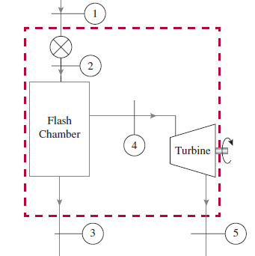 A pump steadily draws water from a pond at a volumetric flow rate of 0.83 m3/min through a pipe having a 12-cm diameter inlet. The water is delivered through a hose terminated by a converging nozzle. The nozzle exit has a diameter of 3 cm and is located 10 m above the pipe inlet. Water enters at 20 °C, 100 kPa and exits with no significant change in temperature or pressure. The magnitude of the rate of heat transfer from the pump to the surroundings is 5% of the power input. The acceleration of gravity is 9.81 m/s2. Determine (a) the velocity of the water at the inlet and exit, each in m/s, and (b) the power required by the pump, in kW. [20M]
4. As shown in Figure 1, saturated liquid water at 1.0 MPa is throttled in an expansion valve to a pressure of 500 kPa, which then flows into a flash chamber. The saturated liquid exits the chamber at the bottom while the saturated vapor, after exiting near the top, expands in an isentropic turbine to a pressure of 10 kPa. Assuming all components to be adiabatic, and a steady-flow rate of 10 kg/s at the inlet, determine (a) the quality at the turbine exit, (b) the power produced by the turbine in kW. ***What‑if scenario***: (c) What would the turbine power and exit quality be if the saturated liquid entered the system at 1.5 MPa? Assume atmospheric conditions to be 100 kPa and 25°C. [20M]

**Fig. 1**

1. 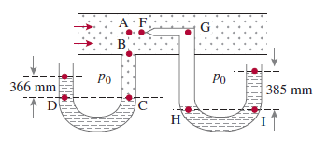 Carbon-dioxide (CO2) gas at 30°C is flowing in a pipeline with diameter 0.1 m and at a velocity 50 m/s. Calculate the pressure read by the two mercury manometers (Fig.2), when (a) one is connected to the wall and (b) the other is connected to what is called a *pitot tube* that points against the flow. The barometer reads 762 mm of Hg, *g* is 9.80 m/s2, and ρHg = 13,640 kg/m3. [10M]

**Fig. 2**